Correlation between particle size and thermoluminescence response of beta irradiated hpht synthetic nanodiamond

C.F. Ruiz-Valdez^{1,*}, R. Meléndrez², D. Berman-Mendoza², K. Santacruz-Gomez¹, V. Chernov², M. Barboza-Flores²
¹ Departamento de Física, Universidad de Sonora, Hermosillo, Sonora, 83000, México
²Departamento de Investigación en Física, Universidad de Sonora, Hermosillo, 83000, México
*e-mail: carlosfr.ruizva@correoa.uson.mx

Diamond based dosimeters are desired due to its tissue equivalent atomic number as well as being a non-toxic material. In this work, we present thermoluminescence (TL) properties of HPHT synthetic nanodiamond powders with mean particle sizes of 60, 140, 380 and 660 nm irradiated with up to 3 kGy of ⁹⁰Sr-⁹⁰Y beta particles.
Particle size of the powders was determined with Dynamic Light Scattering technique and with image processing using TEM micrographies. For all nanocrystalline powders, Raman spectra obtained using a He-Ne laser (632.8 nm) showed the characteristic 1332 cm⁻¹ diamond peak corresponding to the sp³ hybridization of diamond. Beta irradiation and TL measurements were performed with a Risø TL/OSL reader, model TL-DA 20.
The TL glow curves reveal one broad TL band from 373 – 623 K. All the samples showed a lower temperature shift of the TL maxima when the received dose was increased. The maximal TL response (integrated TL between 373 and 673 K) was found for the powders with the mean particle size of 660 nm.
Linear behavior of the dose response was found in ranges up to 1.5 kGy for four different samples although the sample with smaller particle size showed an even greater linearity range increasing up to 3 kGy. These results could set the groundwork for a proposed personal diamond based thermoluminescent dosimeter.

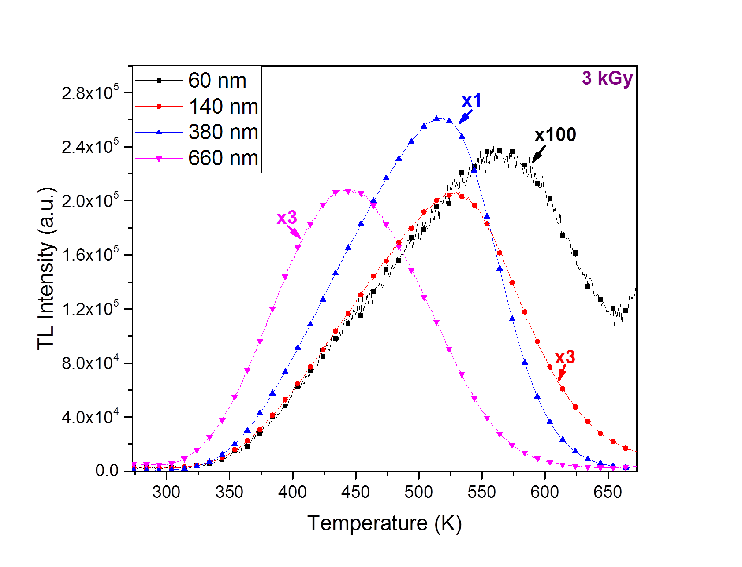 | 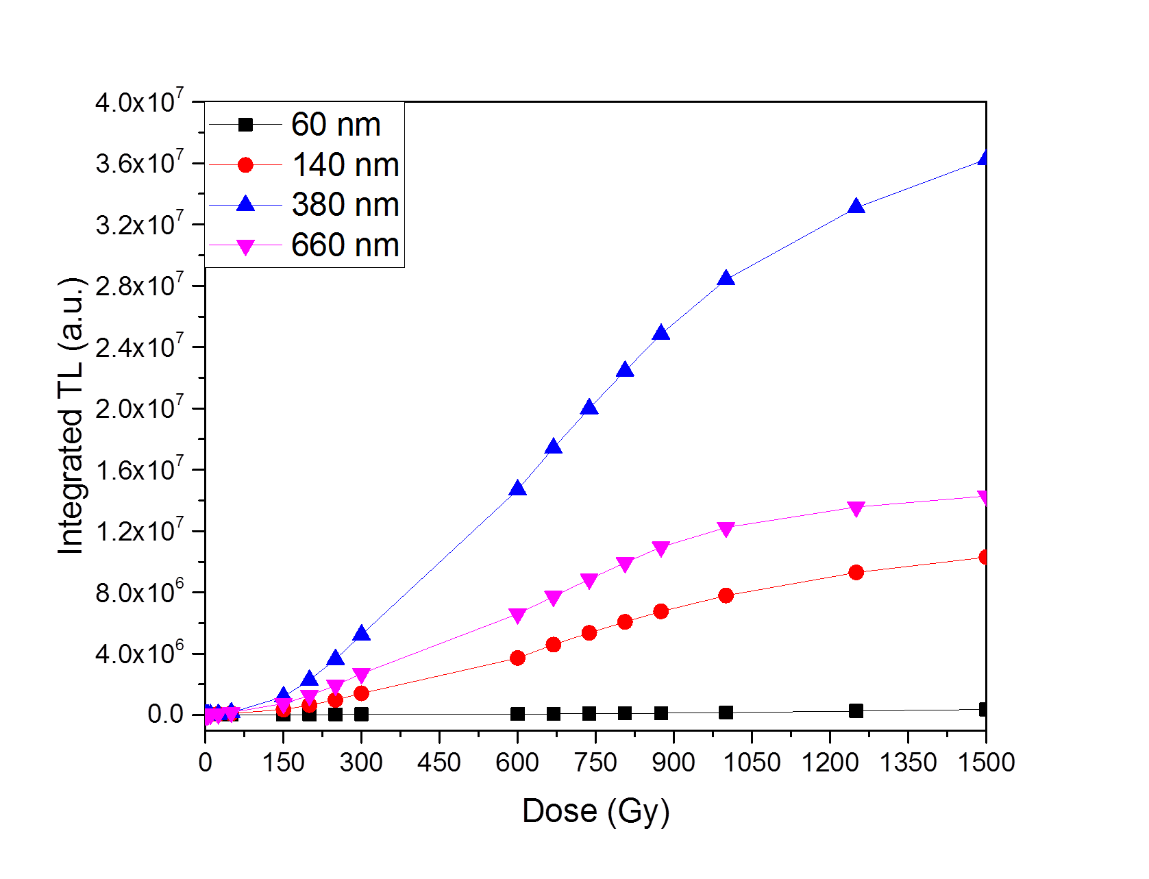
Figure 1 – HPHT nanodiamond TL glow-curves for all the samples. | Figure 2 – HPHT nanodiamond dosimetry curves. TL response was integrated for all the samples along the measured temperature range.

Referencias

[1] F. Schirru, I. Kupriyanov, B. Marczewska and T. Nowak, "Radiation detector performances of nitrogen doped HPHT diamond films," Physica Status Solidi A, vol. 205, no. 9, pp. 2216-2220, 2008.
[2] N. Kristianpoller, D. Weiss and R. Chen, "Irradiation effects in semiconducting diamonds," Physica B, Vols. 308-310, pp. 612-615, 2001.
[3] P. J. Dean, "Bound Excitons and Donor-Acceptor Pairs in Natural and Synthetic Diamond," Physical Review, vol. 139, no. 2A, pp. 588-602, 1965.
[4] P. B. Klein, M. D. Crossfield, J. A. Freitas Jr. and A. T. Collins, "Donor-acceptor pair recombination in synthetic type-IIb semiconducting diamond," Physical Review B, vol. 51, no. 15, pp. 9634-9642, 1995.
[5] J. Nahum and A. Halperin, "Thermoluminescence and the relation between thermal and optical activation energies in diamond," J. Phys. Chem. Solids, vol. 24, pp. 823-834, 1963.
[6] G. Garlick and A. Gibson, "The electron trap mechanism of luminescence in suphide and silicate phosphors," in Proceedings of the Physical Society, 1948.

